Student Title: Enns, Chris OL 344 Assignment 4
Student Date: July 6, 2018
Online Learning: OL 344 Adapting to Climate Change: Sustainable Implementation.
Center for Sustainable Development http://www.csd-i.org/

Assignment Four. Project Launch: Leading a Participatory Workshop in a CBA Long-term Skill Set
Part 1

The training on soil and water conservation through the Farming God's Way methodology involved three steps: 1) A detailed 3-day workshop in Kijabe Kenya with program staff to train them in the principles of conservation agriculture and Farming God's Way, and to prepare them for training others (this took place in March), 2) A short demonstration to select farmers in Wagete to help them prepare a demonstration garden in the dry season for other farmers to learn from (this happened in May), and 3) A future workshop for a larger group of farmers in the community just before the rains come in September/October so farmers can prepare their fields for the rains using these principles. In this assignment, I can write about the first two components only as the third one is yet to take place.

STEP 1) FARMING GOD'S WAY TRAINING IN KIJABE KENYA

In March, I took eight program staff from AICT MUD and our other partner organizations in Tanzania to join our Kenyan and Ugandan counterparts in Kijabe Kenya for an intense three-day training workshop on Farming God's Way, provided by the organization Care of Creation. In that workshop, the program staff were taught about the key principles of conservation agriculture:
- minimal tillage
- use of a cover crop or mulch to cover and protect the soil
- crop rotation
- the importance of following specific and exact principles - distance between plants, distance between rows, depth of planting, timing of planting...
- the importance of planting trees for improving rainfall and health of the soil

The participants were very impressed with this new agricultural approach, as it was such a different way of farming from what farmers have done in the past, particularly the new ideas of covering the soil to protect it from the sun, not ploughing up and wrecking the integrity of the soil, and following very specific planting instructions. They were told that with all the erosion and water runoff that happens in our fields, soil is one of the biggest exports of East Africa, and then were shown the difference that covering soil with mulch or grass can make for protecting against runoff and erosion, and helping the rain be absorbed into the soil.

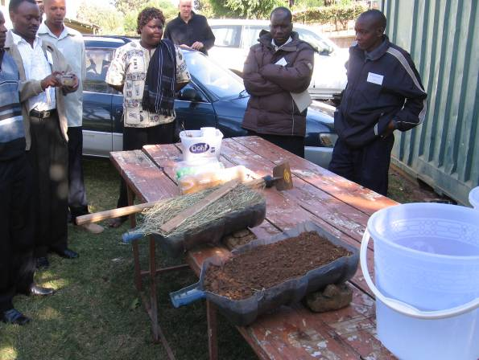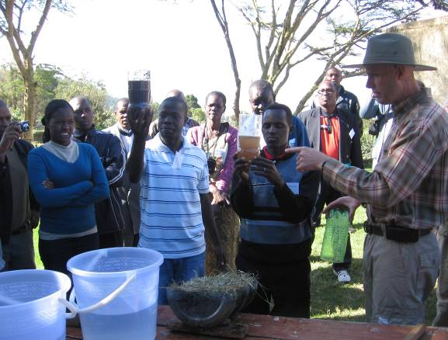
The bottle on the left is runoff from the bare soil - lots of brown dirty water; the bottle on the right came from the covered soil - not much water runoff and very little soil came with it.

Then it was time to go to the field and prepare a demonstration plot called a "Well-watered Garden". Participants learned how to make a teren rope consisting of a long string with bottle caps squeezed onto the rope at 60 and 75cm intervals, depending on which axis of the field they were using it for. They used these ropes to square off their field, and then make rows and markings along each of these rows at these intervals to form planting stations. In these stations, they learned how to best dig up the soil to make a hole at the correct depth, put some lime at the bottom, cover that with some soil, put some fertilizer (natural or man-made), cover with more soil, then plant the seeds at the correct depth, and then cover with more soil to be flat with the surrounding ground. Then they gathered mulch in the form of leaves, twigs, crop residue, and laid a thick blanket over the soil to protect it from the sun's harsh heat. Here's some pictures from these steps:

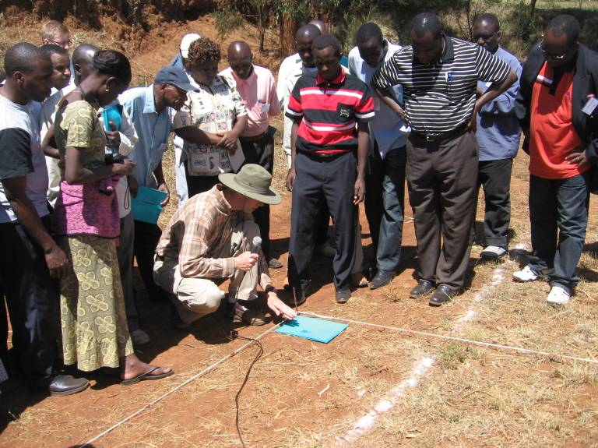
Squaring and marking the boundaries of the field, using the teren ropes, a piece of paper, and large nails.

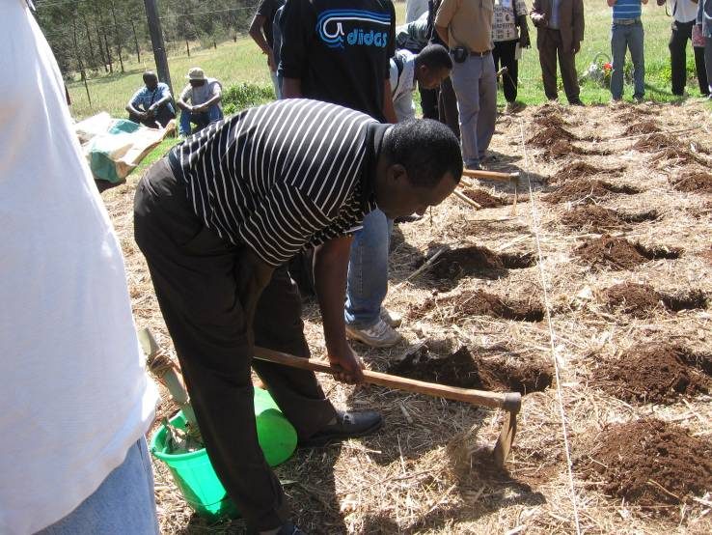
Learning how to dig planting stations beside each of the bottle caps on the teren ropes. Depth and angle of digging are very important to create right hole for the inputs and seeds.

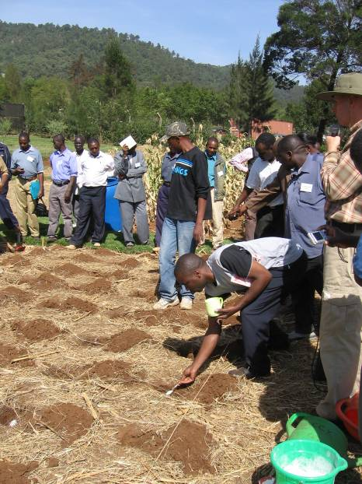
Applying a spoonful of lime to each planting station to help restore nutrients in soil that has been poorly farmed for many years.

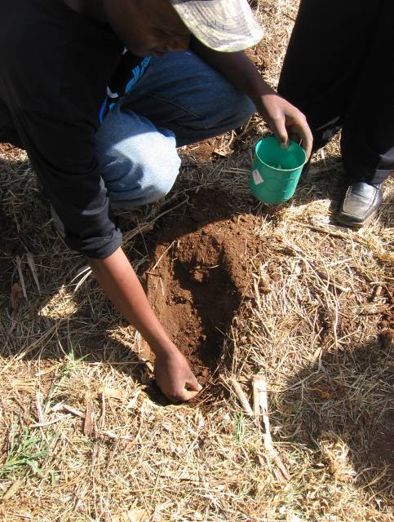
Planting seeds at the proper depth and distance from the edge of the hole to ensure maximum benefit from the fertilizer.

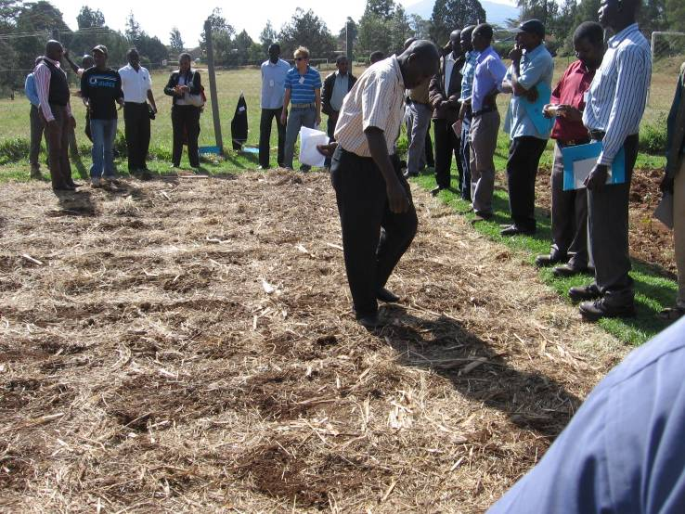
Checking each of the planting stations for proper digging and planting technique.

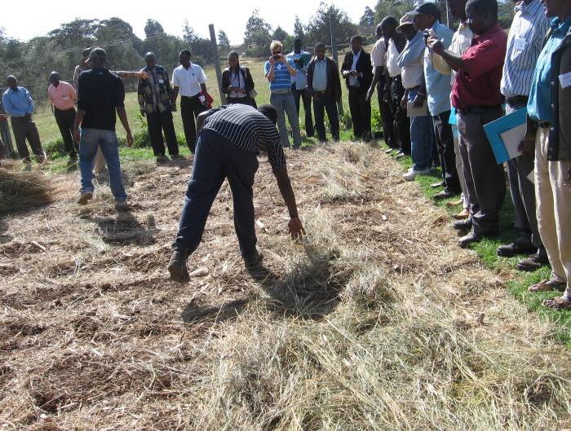
Covering the planted soil with mulch, or "God's blanket".

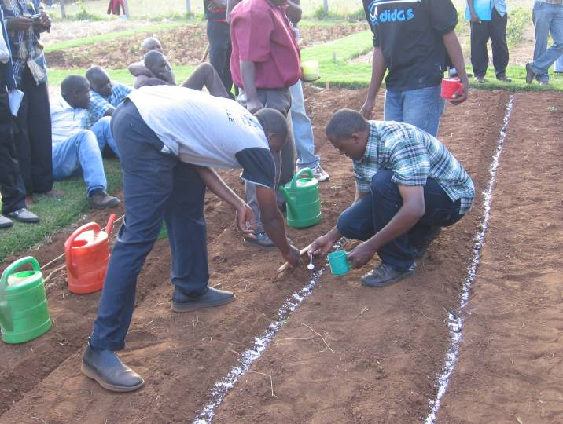
Plants like beans are planted in a shallow row like this instead of in individual planting stations.

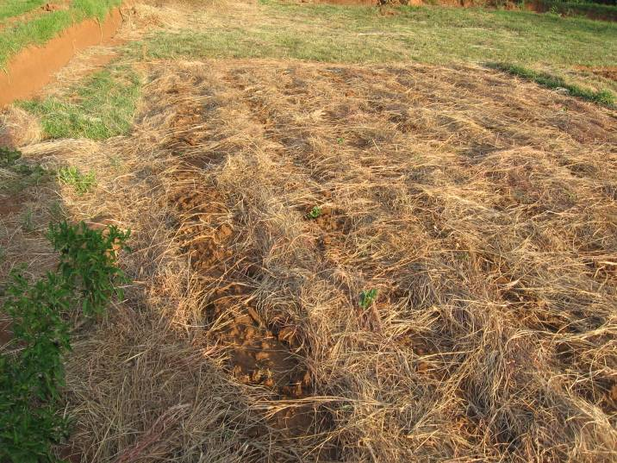
The finished field, ready for the rains to come. As this was a demonstration garden in the dry season, the farmer would have to water the soil regularly for the next few weeks to help the crops emerge. For regular application, the farmers would have marked out the holes ahead of time and then just planted the seeds after the first rain.

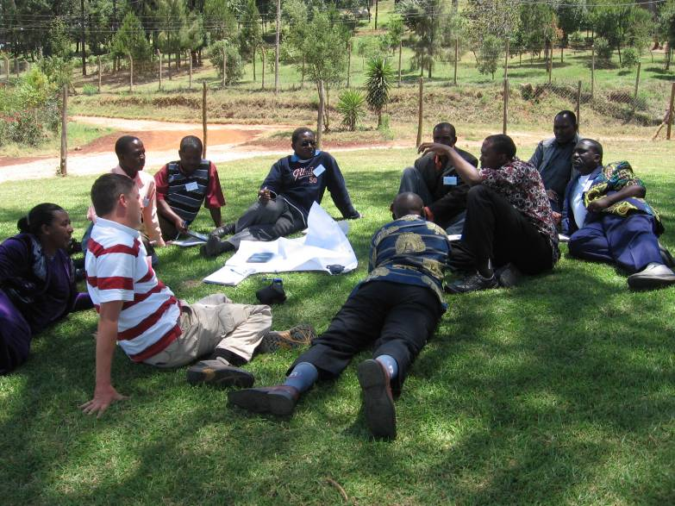
My partner program staff discussing plans with me for how they would like to bring this training to their communities.

At the end of the workshop, the program staff that came with me were very excited about the possibilities this would have for the farmers they work with. A couple of them told me that this was the most inspiring workshop they had ever been to (and they have been to a lot of workshops)!

STEP 2) TRAINING FARMERS IN WAGETE TO PREPARE A DEMONSTRATION FIELD

A few months after the Kijabe training, the AICT MUD staff led a small workshop in Wagete in May with about 10 farmers to teach them the principles that were taught in the Farming God's Way workshop and to work with these farmers to prepare a "well-watered garden". The goal was to create a small demonstration garden that would show other farmers in the area the principles of how to plant a field using conservation agriculture and the benefits that it would provide compared to conventional agriculture. AICT MUD will then conduct a larger scale training in Wagete in late August or early September just before the rains come so that the fields will be ready and the seeds planted at the right time to be irrigated by the rain.

In the training, the participants were very surprised by the difference in water and soil run-off in the bottle demonstration, and saw what a difference simply covering the soil could make for helping the field retain moisture more effectively. The farmers used a teren rope and the same tools as the kijabe workshop to measure out their field, and planted half of it with FGW principles, and half without any soil cover. They were very anxious to see the difference that this would make in their fields.
The training staff reported to me that everybody felt the workshop was a great success and the farmers were excited to try out these new principles and see if it really could reduce runoff and improve their harvests.

Although I was not present during this workshop, I did get to go visit the community about two months later and talk with a few of the farmers and see the results from their fields. The difference between the Farming God's Way portion and the conventional portion was significant, and the farmers were amazed at the results and very eager to show them to me. The aspects that stuck out to them the most were:
- The crops were very healthy and well spaced
- The crops were growing very well in spite of the small amount of water they were using to water them; the conventional half looked completely dry
- With the proper spacing that they were taught, they could plant a lot of crops in just a small space so farmers could get a good harvest from a small field.
- They said in previous years, they would use a lot of seeds, time and effort to plant their fields, but get almost no harvest out of it which was very frustrating. With this conservation agriculture plot, all the seeds and work they had invested were producing healthy plants which greatly excites them
- The farmers especially like the simplicity of providing cover on the soil and seeing the difference that made for the temperature and moisture level of the soil.

Overall, the Wagete farmers are feeling very hopeful that this can improve their agriculture in the future, and are looking forward to seeing the difference in output when they harvest the crop. They also have many questions though and will need guidance as they implement these new ideas.

The program partners and I feel that this small scale agricultural training and demonstration plot has been very successful in achieving its goals as other farmers can clearly see the benefits that conservation agriculture can provide for improving soil and water conservation in their fields, maximizing the results of their work and inputs, and increasing efficiency of planting in small plots. When the larger scale training is implemented, farmers seeing this plot will be very motivated to learn and try out these techniques for themselves.

I did not get any pictures yet from the actual training in Wagete, but here are photos of the field from my visit two months later.

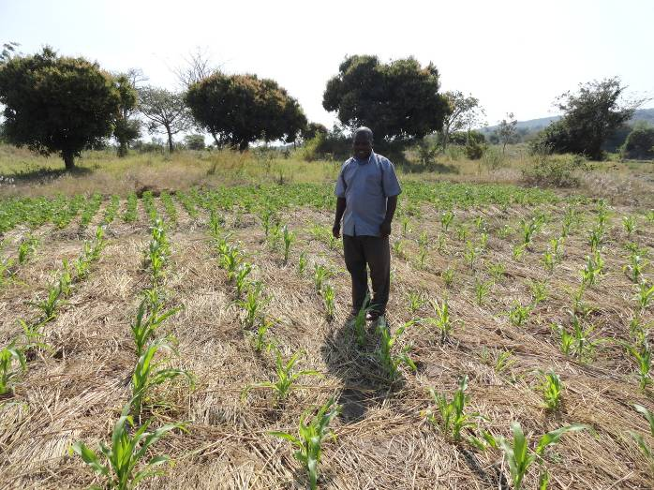
Pastor Timothy Paul of Wagete proudly standing in the middle of his group's conservation agriculture demonstration garden of maize, in the middle of the dry season. Note the straight rows and specific spacing.
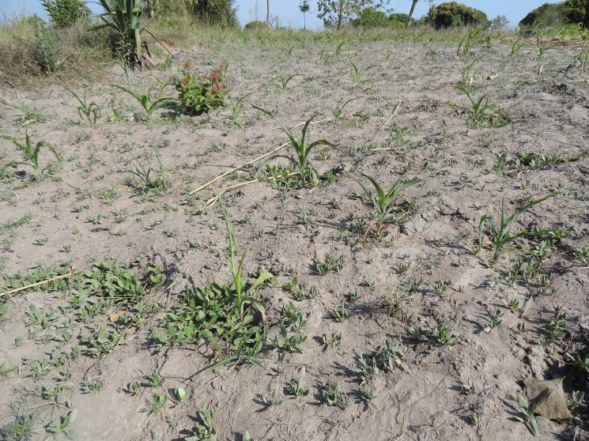
The results after two months on the half of the field that was planted in the conventional way.

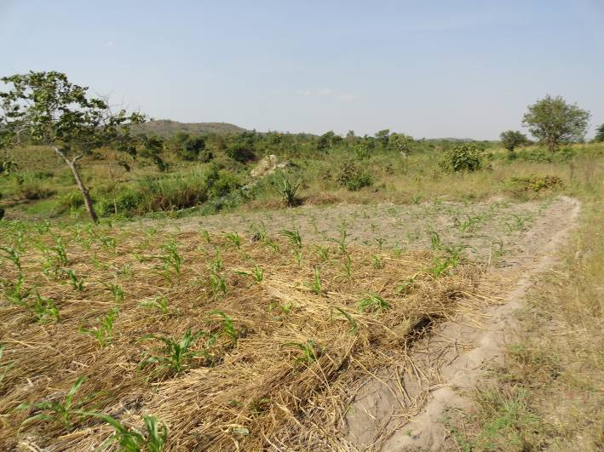
A comparison shot showing the conservation agriculture (foreground) and the conventional agriculture plots (background) planted side by side, on the same day and with same amount of water each week

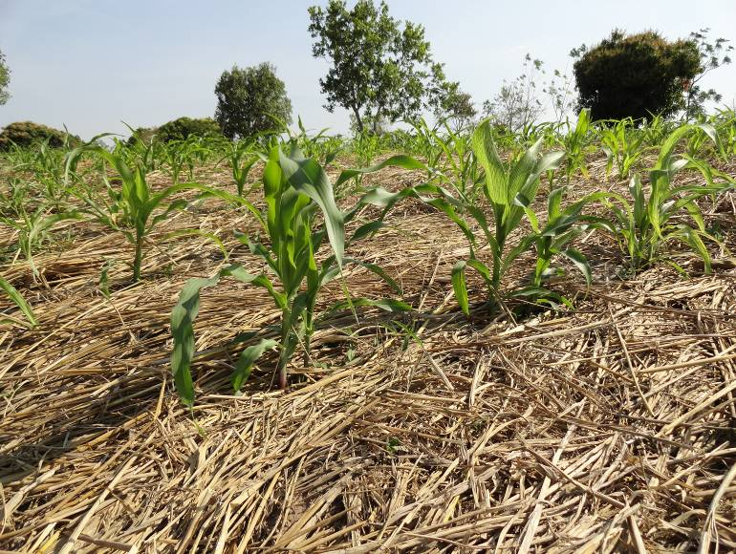
A close-up shot of the maize plants, equally spaced, and with the soil protected by a mulch layer of dried rice stalks.

