Center for Sustainable Development https://training.csd-i.org/
Email and Homework Etiquette: The Rules of the Game
Thank you for enrolling in an online course at the Center. The Center offers a number of courses to a growing audience of participants. It can be challenging for us to manage hundreds of incoming emails. We have created the simple system described below to make the management of emails and documents quick and efficient.

THE RULES OF THE GAME. Please read the rules below and follow them carefully.
Email Etiquette
1. One correct CSDi Email address. Use only the one specific email address that you were given for your online course which we sent to you in your Welcome Letter.

2. Write a new subject line for every Email. We encourage you to write us, but please start with a fresh e-mail with a new subject line. With hundreds of e-mails flowing for system, new messages that are using old e-mails that have been replied to can be mistaken for old messages that have already been read.

3. Labeling System. We use a labeling system for all email subject lines, document file names, and homework titles; they each need to be exactly the same.
- Last name, First Name, Course Number, Assignment Number.

Email Subject Line. If you are sending in a homework assignment, please use the following format:
- Magee, Tim OL 101 Assignment 1

Homework Title. At the very top of your homework please follow exactly the same format as your e-mail subject line:
- Magee, Tim OL 101 Assignment 1

Document File Name. Save your file to exactly the same format that you used in your email subject line and that you used at the top of your homework.
- Magee, Tim OL 101 Assignment 1

We are very engaged in reading all assignments. We get to know each of your projects. We frequently refer back to earlier assignments for information. By having consistent subject lines, homework titles and file names, all of your assignments are grouped together and are quick for us to find. The illustration below helps to see why the file name is important for finding documents; this is only a few of the students in a very large class. Thank you!
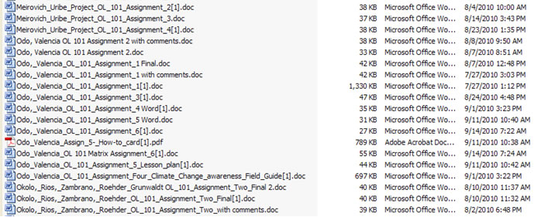
4. Photos. Please send us photos – but send them as simple attachments. Please don’t compress (zip) them or upload them to secondary download sites.

Homework Etiquette.
1. Written Homework Format. Please follow exactly the homework format of the Magee Project Example or the downloadable template for the assignments that we may provide. At the end of 12 weeks, you will assemble your assignments into a donor presentation based upon accepted donor standards; this is why your assignments need to follow the exacting formats.

Simply open our example or template, put your named title and date at the top, save it with the same named title and type right over the top of what we have provided to create your assignment. Please don’t change the formatting of the document.
So now
2. Spelling and Grammar. Please, please, please, run Spell Check and Grammar Check on all documents before you send them to us.

3. File types. We only accept Microsoft Office files. We do not accept.rtf files, zipped or compressed files. We only accept files as attachments; we don't accept links to files stored at download sites.

4. Final Version of Assignments. We will make suggestions to each of your assignments. Typically, they are designed to keep your assignments in alignment with course direction. One assignment is the building block for the next assignment. So, it it's important to stick with the final versions that were submitted and commented upon.

Thank you for your patience and understanding. Now let’s have some fun in the course! Copyright © Tim Magee

