1,000 small children from 500 families will enjoy improved nutrition & food security through a community garden, food surplus donations & a client choice food pantry program

COMPELLING NEED
Imagine you are the parents of children who are chronically undernourished.
If you are a single mother in the Inland Empire, it is a possibility that you may depend on Food Pantries to feed your children. But, it's not enough. In a recent survey food pantry clients listed challenges that included 1) a lack of access to sufficient fruits, vegetables, and meat products, 2) a lack of a garden for raising their own vegetables, and 3) an inability to choose which food products go into the food boxes and in which quantities. These challenges impact their children's nutrition: Chronic undernourishment leads to reduced physical and mental development, and insufficient energy to concentrate in school. Without adequate education, their children will enter life unprepared to deal with its complexities, such as comprehending a bank statement, a voting ballot, or a newspaper. They may become a target of exploitation and injustice, and remain in the cycle of poverty.

APPEAL FOR FUNDING
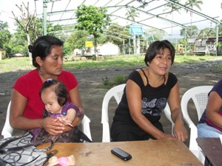
$62,000.00 will help the children of 500 families become sustainably well-nourished and healthy.
Support from the Community Foundation of $62,000.00 will help the Center for Sustainable Development implement a community garden program, a restaurant and grocery store surplus food donation program, and a client choice food pantry program for 500 families in Claremont, California—and four surrounding cities. The program will help their 1,000 children be sufficiently nourished to excel in school. 500 families will begin the rise out of poverty and begin leading healthy, productive lives.

ABOUT YOUR ORGANIZATION
Why invest in the Center for Sustainable Development?
Since 2008, CSDi, a US-based non-profit organization, has been committed to the idea that responding to community identified need with accessible technologies will bring about sustainable, long-term change for families and change that sets a positive example community-wide.

The Center has a unique approach to development: We believe that simple health, hygiene and nutrition interventions allow children to grow up healthfully, participate in family and community activities, and receive an education that leads to a productive future.
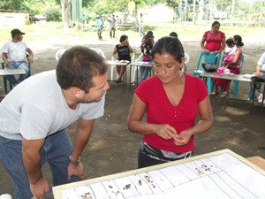
CSDi works to prioritize community-identified need and researches science-backed, solution-oriented activities that work to solve problems. CSDi’s programs include workshops designed specifically for families—combined with a follow-up program to make sure that families are able to adopt the practices.

The Center works cost-effectively, demonstrating a low overhead of 12 percent in 2014. We have long-standing collaborative relationships with a number with donors, non profits and government institutions—relationships that ensure the success and sustainability of our projects.

HOW YOU PLAN TO SOLVE THE PROBLEM
This Proposal: Improved nutrition & food security through a community garden, food surplus donations & a client choice food pantry program.
With this proposal, the Center wants to help 500 families set an example and begin the process of rising out poverty through:
- A community garden program that includes workshops, supplies and follow-up on:
  - The basics of family nutrition and how a family garden can provide food security
  - Planning, designing, planting, and caring for a nutritious family garden
- A restaurant and grocery store surplus food donation program that includes:
  - A survey to gauge interest and also to better understand the things community members would enjoy from this program
  - Working with a nutritionist to better understand a healthy diversity of products to request from restaurants and grocery stores
- A client choice food pantry program that includes:
  - A survey to gain a better understanding of community member food needs and preferences
  - Working with a nutritionist to fill in gaps in the needs list and to develop a simple family nutrition workshop for community members and staff alike
  - Workshops and follow-up in family nutrition and client choice planning for nutrition and follow up for 3 months

This will be an empowering program for these families. Simple concepts such as a balanced diet and the need for micro-nutrients will have immediate health impact for the families.
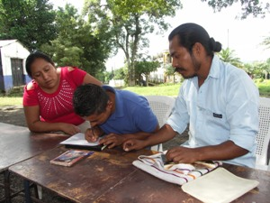
Short-term investments in fruit and vegetable gardens rich in Vitamin A, calories, proteins and fats will begin to show long-term, sustainable impact within three months.

For example, in the community garden program, community members will first choose appropriate vegetable crops by working with a nutritionist to discuss plants rich in vitamin A, and fruits that offer protein and fats like avocado. This will be followed by a workshop that will help participants have a successful first-year garden, and the provision of seeds for nutritious, vitamin A rich food crops in their new gardens.

MEASUREMENT OF SUCCESS
How do we know our programs will work?
Scientific studies show that home gardens can provide 60% of leafy vegetables, and between 20% and 50% of all fruits and vegetables consumed by households. Improved nutrition boosts the body's immune system protecting children against infections. Vegetable gardens have shown evidence of significantly reducing the number of undernourished children in impoverished communities.

BUDGET NARRATIVE
The Center for Sustainable Development is requesting of the Community Foundation $62,000.00 for this $92,860.00, 14 month project, that will improve the lives of 500 families. The funds will launch a restaurant and grocery store donation program and a client choice food pantry program—and provide 16 workshops in nutrition and in planting family fruit and vegetable gardens for food-security. It will also include a range of fruit and vegetable seeds for the gardens of 100 families. Each workshop activity is reinforced by a follow-up program. The Center will provide 33% cost sharing of $30,860.00.

CONCLUSION
Overall, we believe that our program dovetails well with the Community Foundation’s giving priorities, especially those aimed at supporting single head of household families. By partnering with the Center, the Community Foundation will help 500 Inland Empire families increase health, infant and child development, and food security. 1,000 young children will increase their access to education in preparation for careers that will allow them to be contributing members of society and to lead self-sufficient, productive lives. These young adults will in turn encourage their families, their communities, and eventually, their own children to embrace health, food security and education as a means for building permanent pathways out of poverty.

Please don’t hesitate to contact us with questions or to receive supporting documentation.

Sincerely,

Tim Magee
Executive Director
Center for Sustainable Development
Tim.Magee@csd-i.org
https://csd-i.org/

The Center for Sustainable Development specializes in providing informational resources and training in best practices to nonprofit professionals.

